Storage in Kubernates

A PersistentVolume (PV) is a piece of storage in the cluster that has been provisioned by an administrator or dynamically provisioned using Storage Classes. It is a resource in the cluster just like a node is a cluster resource. PVs are volume plugins like Volumes, but have a lifecycle independent of any individual Pod that uses the PV. This API object captures the details of the implementation of the storage, be that NFS, iSCSI, or a cloud-provider-specific storage system.

- root@master:~/capgeminimanifestnov# kubectl apply -f pv.yaml
- persistentvolume/task-pv-volume created

A PersistentVolumeClaim (PVC) is a request for storage by a user. It is similar to a Pod. Pods consume node resources and PVCs consume PV resources. Pods can request specific levels of resources (CPU and Memory). Claims can request specific size and access modes

- root@master:~/capgeminimanifestnov# kubectl apply -f pvc.yaml
- persistentvolumeclaim/task-pv-claim created

apiVersion: v1
kind: Pod
metadata:
name: quota-mem-cpu-demo
spec:
containers:
- name: quota-mem-cpu-demo-ctr
image: nginx
resources:
limits:
memory: "800Mi"
cpu: "800m"
requests:
memory: "600Mi"
cpu: "400m"

apiVersion: v1
kind: Pod
metadata:
name: quota-mem-cpu-demo-1
spec:
containers:
- name: quota-mem-cpu-demo-ctr-2
image: nginx
resources:
limits:
memory: "1Gi"
cpu: "800m"
requests:
memory: "700Mi"
cpu: "400m"
Manifest-Version: 1.0 Implementation-Title: AWSB5Rest Implementation-Version: 0.0.1-SNAPSHOT Build-Jdk-Spec: 1.8 Created-By: Maven Integration for Eclipse

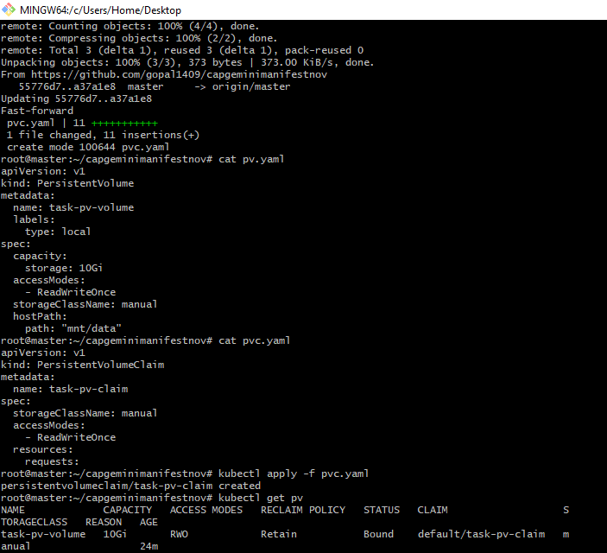

Mapping of PV and PVC is done by giving the same storageClassName.
The STATUS: Bound shows that the mapping is successfully created between the PV and PVC

Namespaces: In Kubernates, namespaces provides a mechanism for isolating groups of resources within a single cluster. Names of resources need to be unique within a namespace, but not across namespaces. Namespace-based scoping is applicable only for namespaced objects (e.g. Deployments, Services, etc) and not for cluster-wide objects (e.g. StorageClass, Nodes, PersistentVolumes, etc).
Namespaces are intended for use in environments with many users spread across multiple teams, or projects
Namespaces are a way to divide cluster resources between multiple users (via resource quota).
We can use labels to distinguish resources within the same namespace

kubectl get namespace or kubectl get ns

Lists all the namespaces
Kubernetes starts with four initial namespaces:

- default The default namespace for objects with no other namespace

- kube-system The namespace for objects created by the Kubernetes system

- kube-public This namespace is created automatically and is readable by all users (including those not authenticated). This namespace is mostly reserved for cluster usage, in case that some resources should be visible and readable publicly throughout the whole cluster. The public aspect of this namespace is only a convention, not a requirement.

- kube-node-lease This namespace holds Lease objects associated with each node. Node leases allow the kubelet to send heartbeats so that the control plane can detect node failure.

